Data Types, Operators and Expressions in C++

LAB # 02



Spring 2022

CSE-102L COMPUTER PROGRAMMING LAB

Submitted by: MUHAMMAD SADEEQ

Registration No.: 21PWCSE2028

Section: C

"On my honor, as student of University of Engineering and Technology, I have neither given nor received unauthorized assistance on this academic work.'

Student Signature: _____________________

Submitted to:

Engr. Abdullah Hamid

(July 2022)

Department of Computer Systems Engineering University of Engineering and Technology, Peshawar

# Lab 2: Data Types, Operators and Expressions in C++

## Objectives

To be familiar with different data types, Operators and Expressions in C++.

## Task Titles:

1. Write a program that takes the temperature in Fahrenheit from the user and convert it to Celsius And Kelvin:

K = C + 273

C = (F – 32) / 1.8

1. Write the C++ code that takes the integer a, b, c, d and e from the user and display the output according to the following equation.

a3 + b – d / b

a (b + c (e + a) / b) - 5

1. Write a program to declare two integer and one float variables then initialize them to 10, 11, and 12.6. Also print the variable values on the screen.
2. Write a C++ program to prompt the user to input 3 integer values and print these values in forward and reversed order.
3. Write a program to swap two variables values with and without using third variables.

**COMPUTER PROGRAMMING LAB # 2**

**Answer #1**

**CODE:** 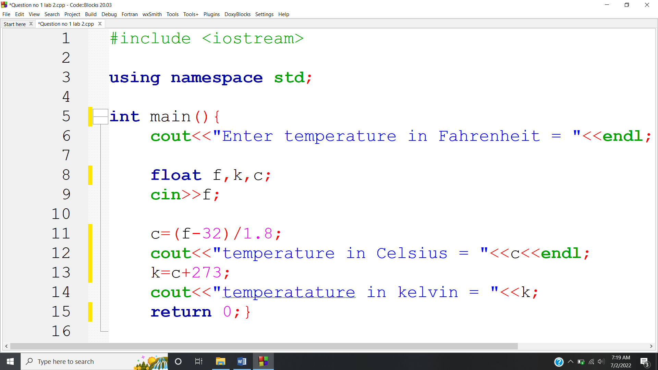

**OUTPUT:** 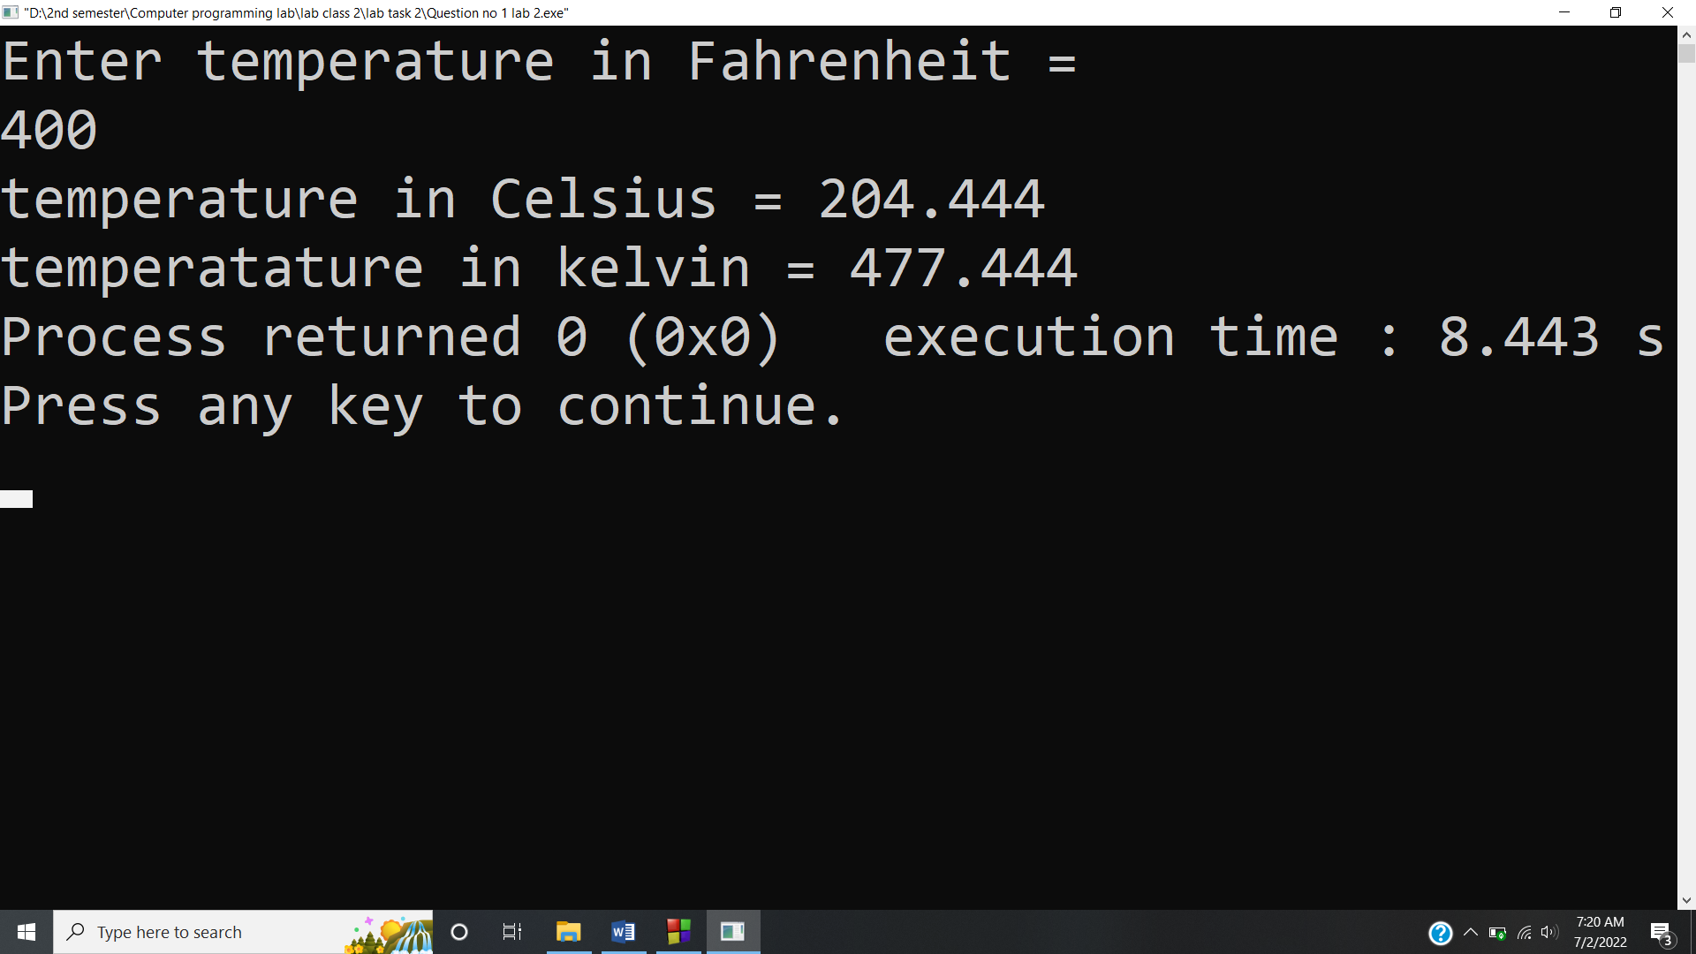

**Answer #2**

**CODE:** 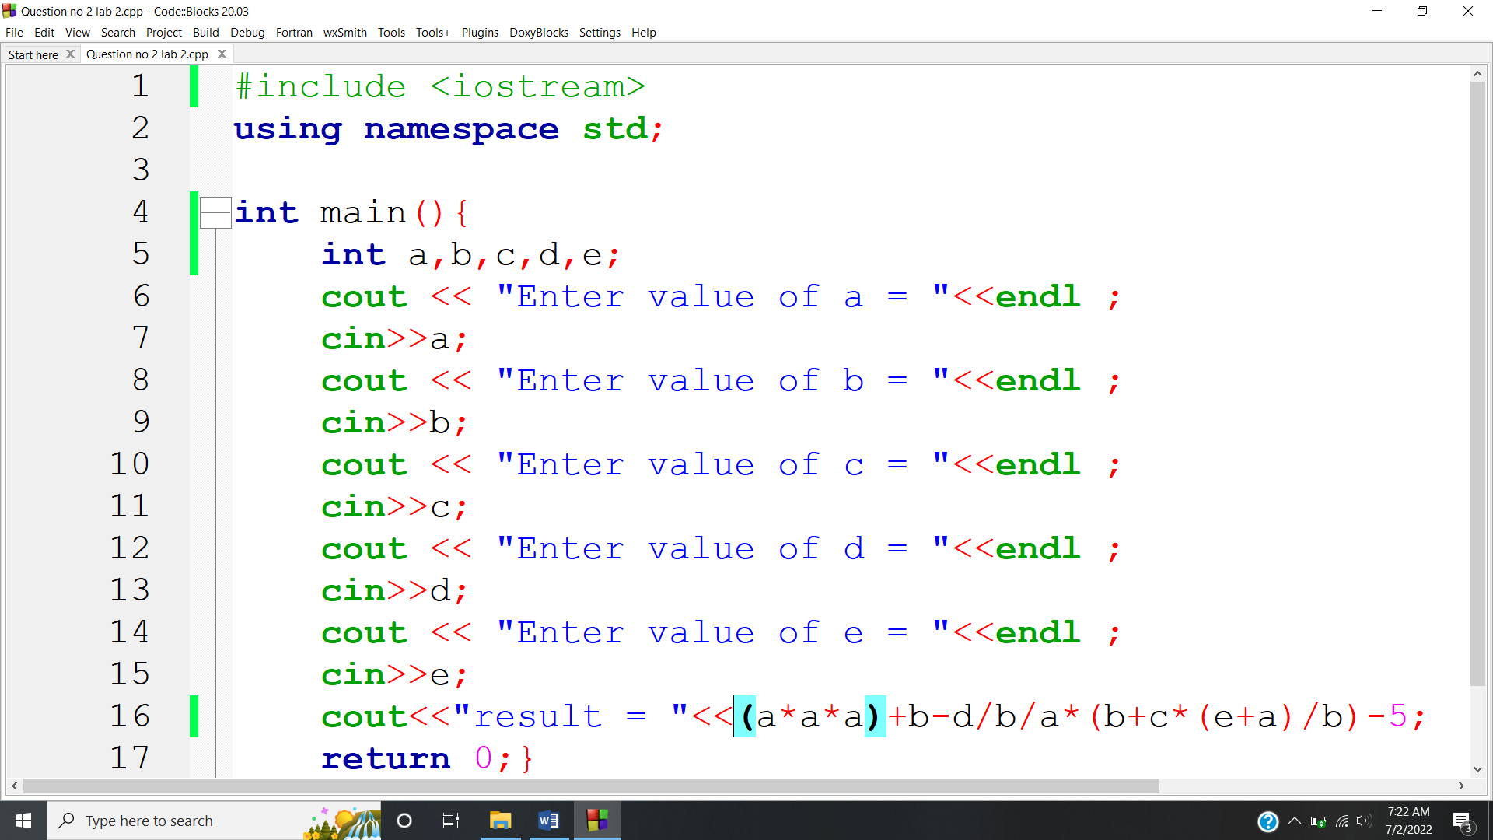

**OUTPUT:** 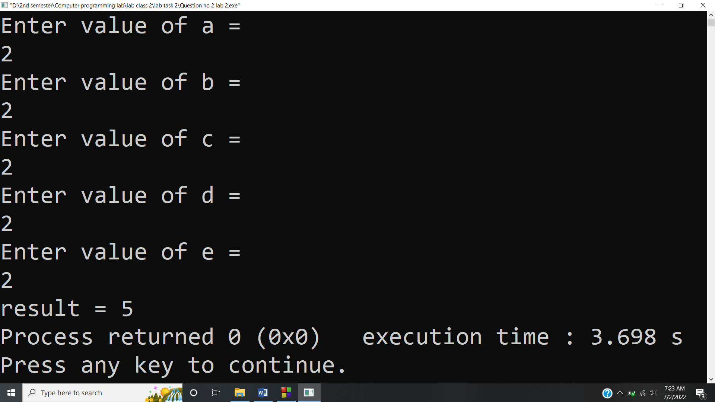

**Answer #3**

**CODE:** 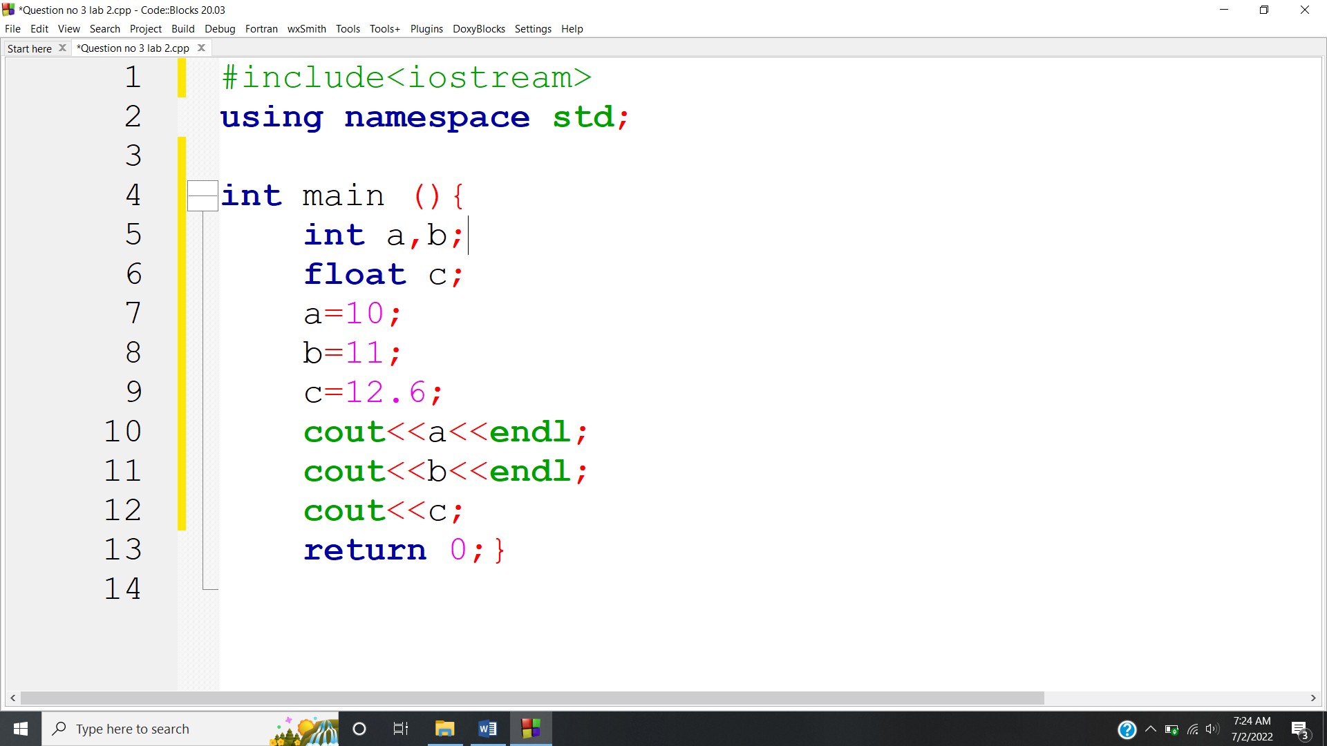

**OUTPUT:** 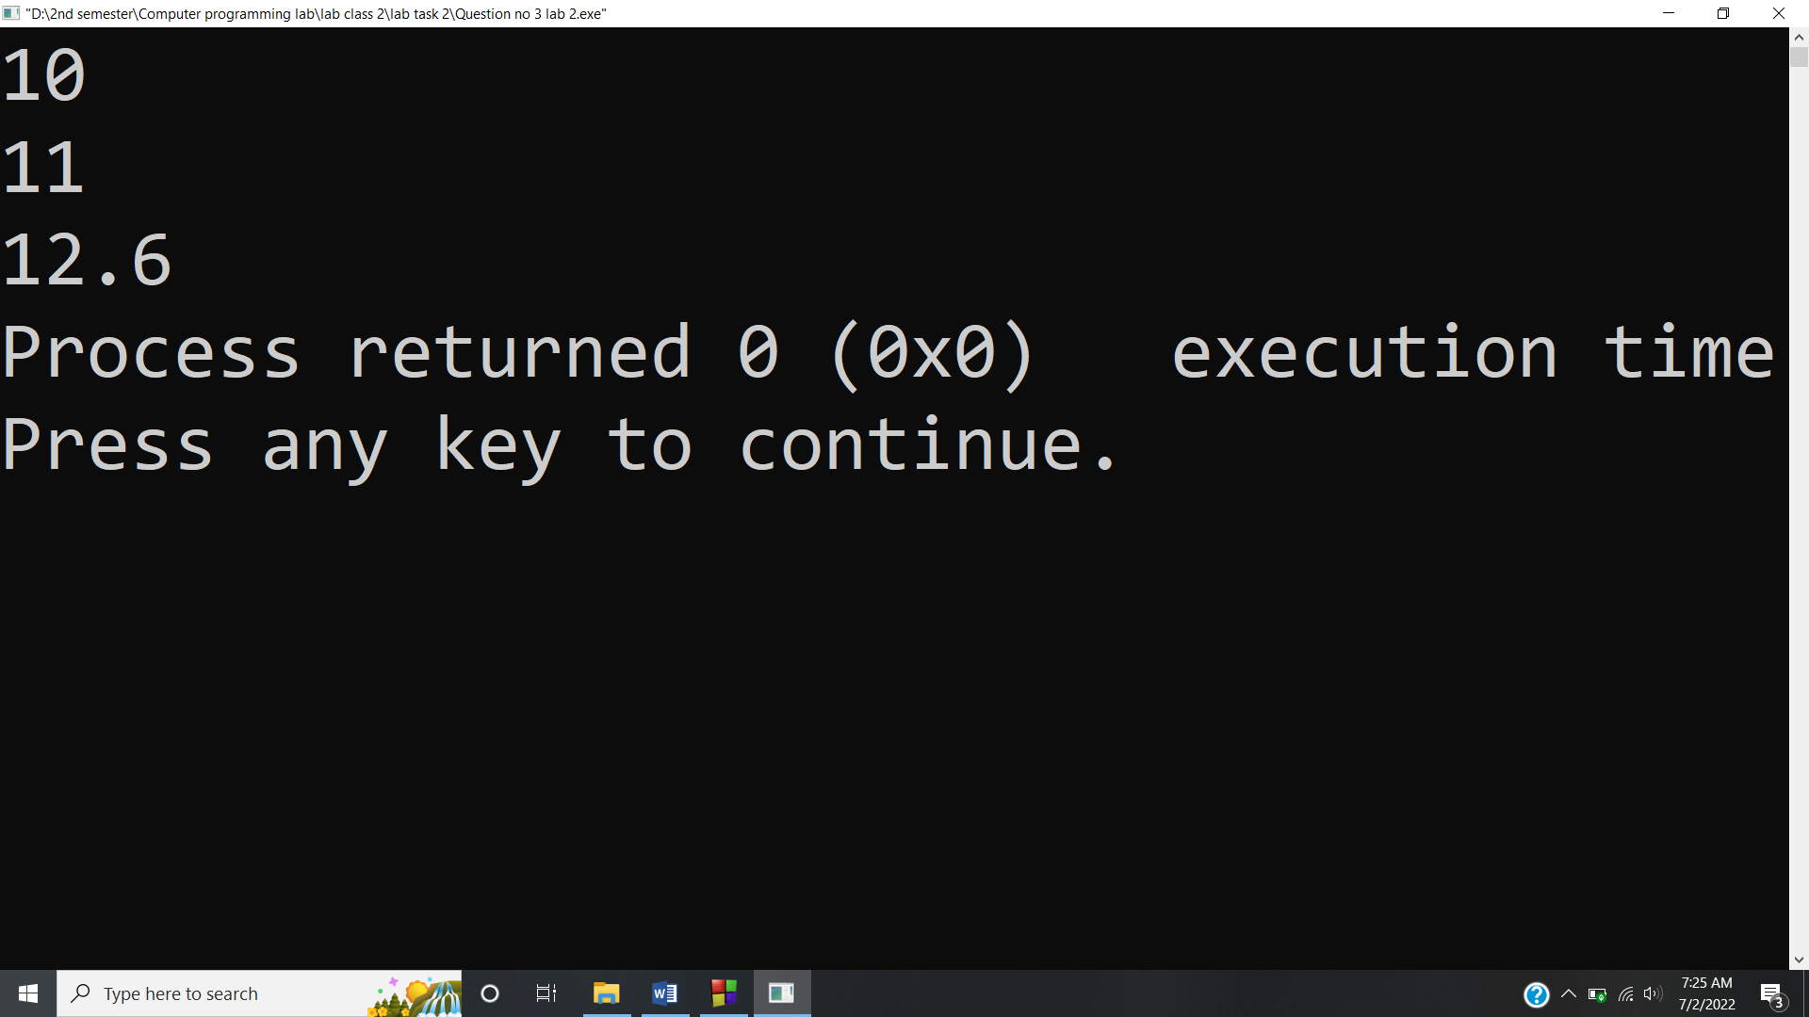

**Answer #4**

**CODE:** 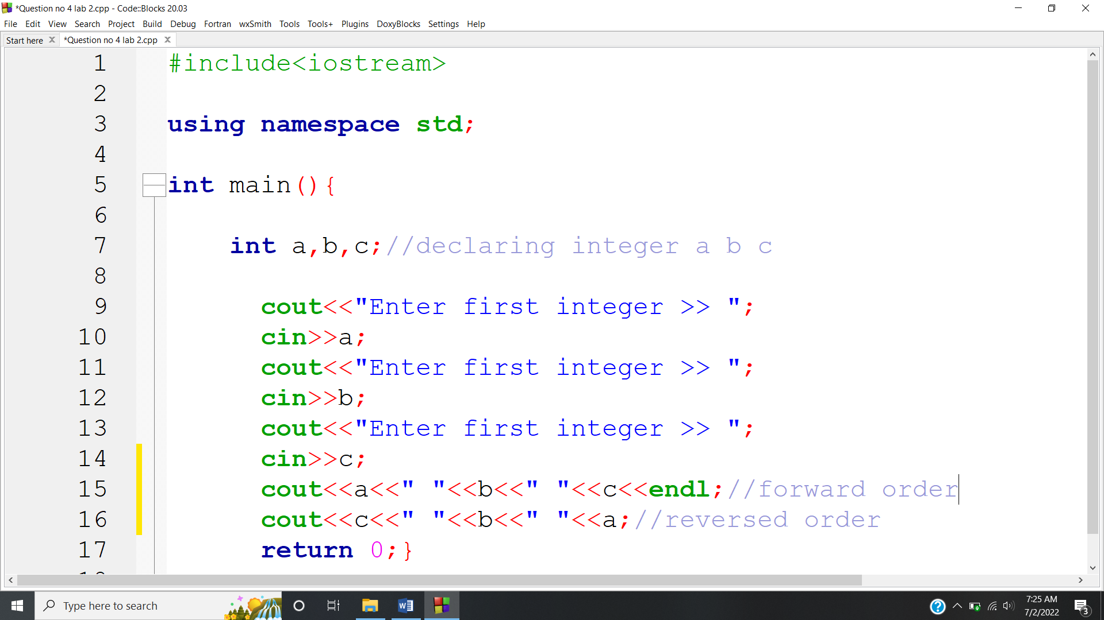

**OUTPUT:** 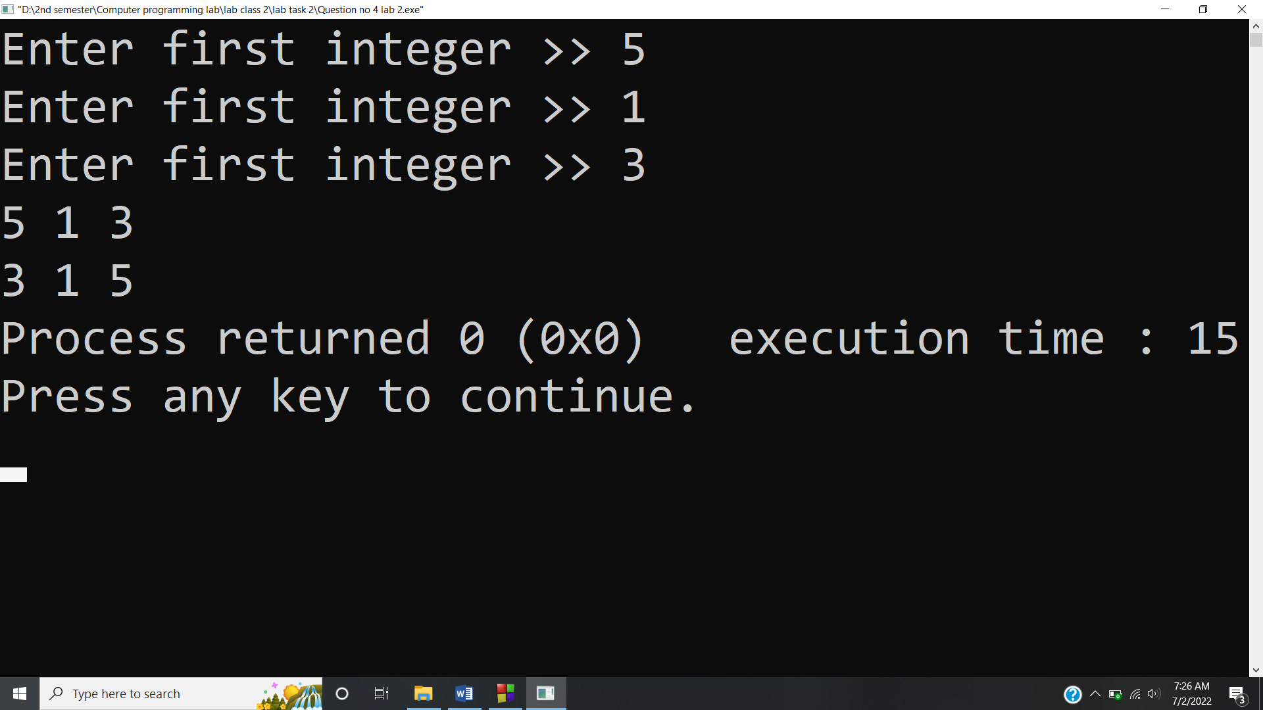

**Answer #5**

**Swapping of two variables with the help of third variable**

**CODE:** 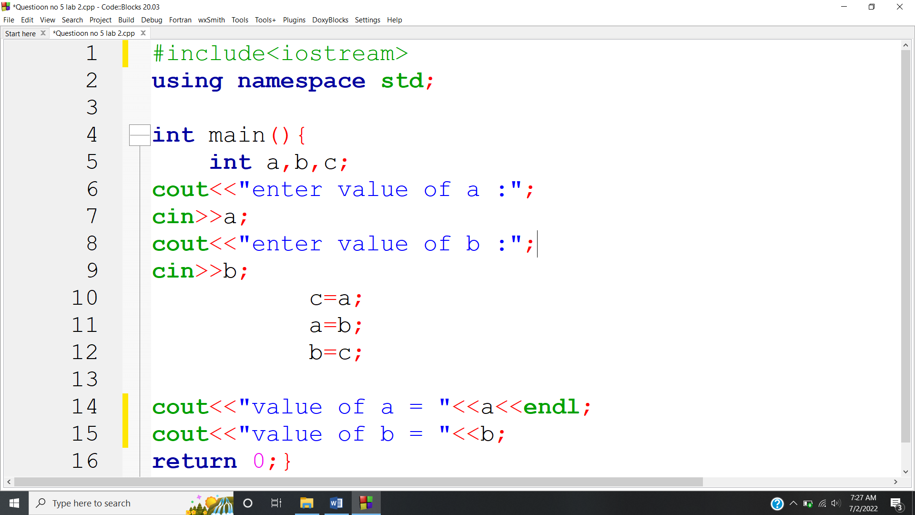

**OUTPUT:** 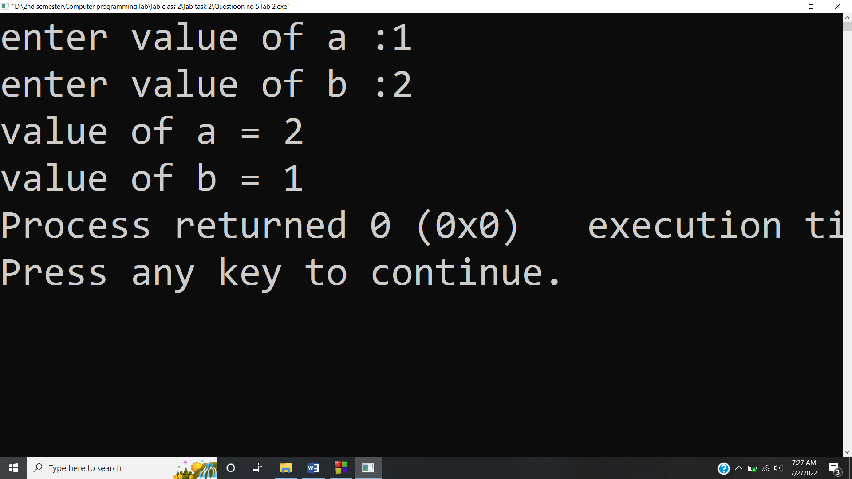

**Swapping of two variables without the use of third variable**

**CODE:** 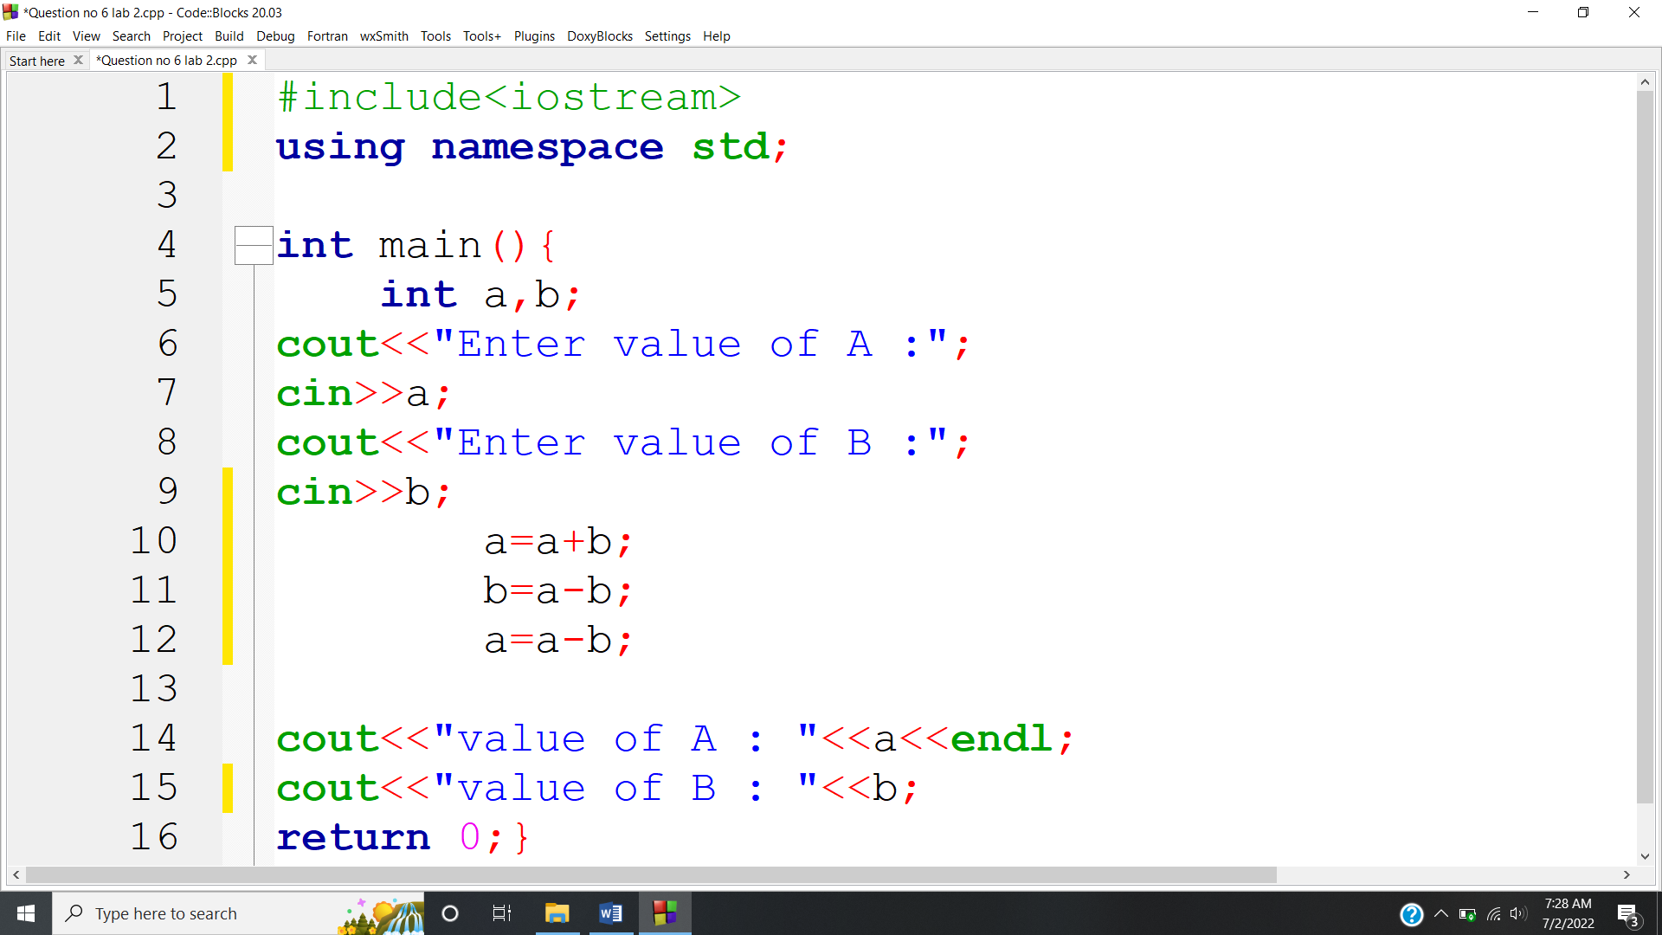

**OUTPUT:** 